SVD GOVERNMENT DEGREE COLLEGE(W)
NIDADAVOLE, EAST GODAVARI DISTRICT-534301
(AFFILIATED TO ADIKAVI NANNYA UNIVERSITY, RAJAMAHENDRAVARAM)
E-Mail: nidadavolew.jkc@gmail.com
DEPARTMENT OF ENGLISH
EXTENSION LECTURE-2026
Date : 04-02-2025
Venue : SVRK GOVT DEGREE COLLEGE,Nidadavole
Organized by : Department of English
Name of the Lecturer : Dr. M. KAMBAIAH, Lecturer in English
Title of the Lecture : MAKING QUESTIONS AND QUESTION TAGS
Type of activity : EXTENSION LECTURE
No of Participants : 56

Introduction
An Extension Lecture was delivered on 4th Feb,2026 at SVR Govt Degree college,Nidadadvole to enhance participants' skills in English grammar, focusing on the formation of questions and question tags. The session aimed to provide practical insights into these fundamental language structures, which are essential for effective communication, exams, and professional writing.

Objectives of the Lecture
- To explain the rules and types of question formation (e.g., yes/no questions, wh- questions, and indirect questions).
- To teach the structure and usage of question tags (e.g., positive/negative statements with matching tags like "isn't it?" or "don't you?").
- To demonstrate common errors and provide exercises for hands-on practice.
- To improve participants' confidence in using these elements in spoken and written English.

Key Highlights
- The speaker began the extension lecture on making questions and question tags include core grammar rules, practical examples, and interactive exercises that boosted participants' skills.
- Yes/No Questions: Invert subject and auxiliary verb (e.g., "You are late" → "Are you late?"). Use "do/does/did" for simple tenses without auxiliaries (e.g., "She likes tea" → "Does she like tea?").
- Wh-Questions: Start with question words (who, what, where, etc.) + auxiliary + subject (e.g., "They went home" → "Where did they go?"). No auxiliary inversion if question word is the subject (e.g., "Who called?").
- Question Tags: Add opposite tag to statements (e.g., positive statement + negative tag: "You like coffee, don't you?"). Match pronouns and use "will you?" for imperatives.
- Common errors highlighted: Forgetting auxiliaries (e.g., wrong: "You like it?"; correct: "Do you like it?") and mismatched tags (e.g., wrong: "He can swim, can he?").

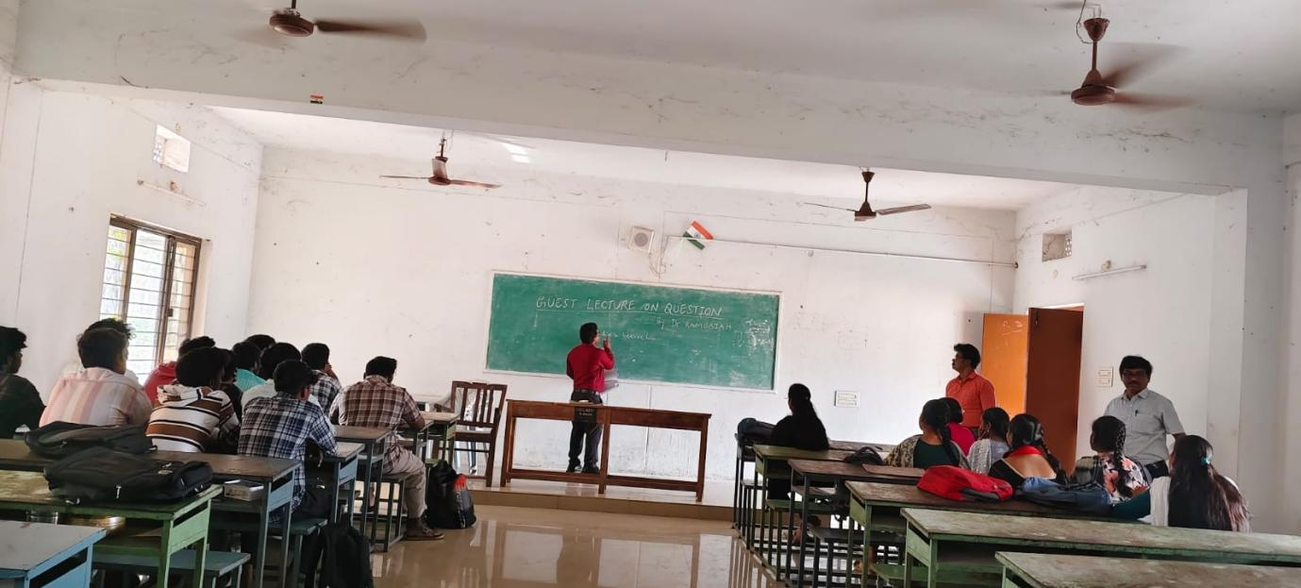
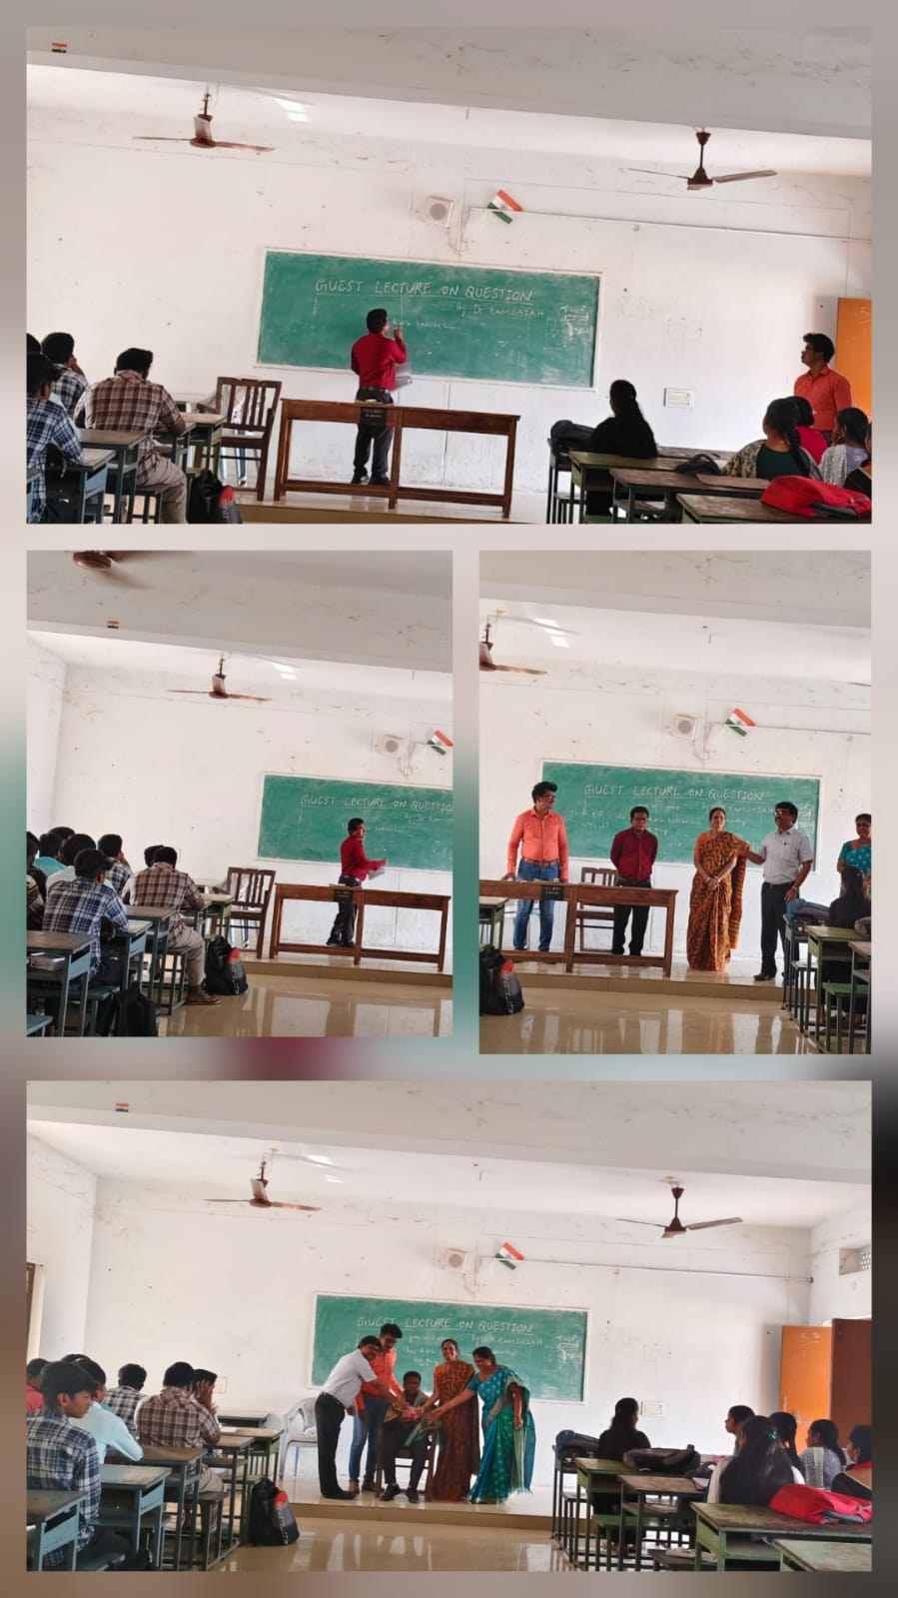
Outcomes
- Participants gained a clear understanding of question inversion and tag rules.
- Over 90% of attendees successfully completed interactive session during the session, showing immediate application.
- Key takeaways included avoiding pitfalls like mismatched tags (e.g., "He can swim, can he?" is incorrect) and adapting tags for modals (e.g., "You must go, mustn't you?").

Feedback

The lecture successfully met its goals, fostering practical grammar skills.Based on informal feedback 80% of the students rated the session “Very Good”. many of the students felt more confident in forming question tags post lecture. The lecture successfully met its goals, fostering practical grammar skills and real life examples.

